**Liberating Your Seder**

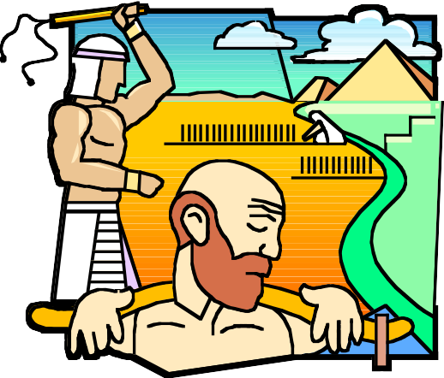

Pesach is the time when we celebrate our freedom and the exodus of our ancestors from Egyptian bondage. It is time we liberate our own Seder with which we remember our past so we can appreciate what freedom means in our own lives. Too many people find themselves sitting stiffly around the dining room, turning pages in a text that seems lifeless and asking only one question, "When do we eat?" the experience is extremely unsatisfying.

Let me suggest some alternatives for your consideration.

First, and perhaps most important, you need to think about who will be at your Seder table. Will there be children present? If so, how old are they? What about the adults? How conversant are they with the Pesach story and the themes that it raises? How fluent are you and your guests in Hebrew?

Next, you should think about different Seder experiences you have had. There is a wonderful exercise you can do to accomplish this. Complete each of the following:

My earliest memory of Seder is...



The best thing at the Seder was...

The worst thing at the Seder was...

My favorite part of the Seder is…

The best Seder I ever attended was... because...

What memories do I wish to create for my children? Grandchildren? Guests?

The answer to all of these questions will be helpful in planning your Seder. With this information at hand, it is time for some homework and creative thinking.

**Setting the Stage**



Start your Seder somewhere other than at the dining room table. A beautifully set table leads to thoughts of a delicious meal and is perhaps a little intimidating to children. Move into your living room or family room where discussion can proceed more easily. Have some throw pillows on the floor for children and get comfortable. You will need to think about safe places for wine cups. Set your Seder plate on the coffee table.

**Holding Off Hunger**



Once you have recited the blessing for Karpas and eaten the greens, bring out a plate of cut up vegetables (carrots, celery, peppers, mushrooms, etc.) This will keep everyone content and allow people to focus on the Seder, not the grumbling in his or her stomach.

**Telling the Story**

Choosing the right Haggadah and using it properly is key. If you are still using the Maxwell House Haggadah or something similar, you should consider investing in new Haggadot, even if people have to share them for the first year or two to defray the cost involved. There are many excellent choices available, some with an accompanying leader's guide. Even if you are not ready to change everybody's text, it is worthwhile for the leader to prepare for the Seder using one of the newer versions which contain explanations, interpretations and discussion topics, not to mention lots of helpful "How to" information. (The Feast of Freedom Haggadah is an excellent starting point. The Pesach Resources document has suggestions for haggadot as well as online resources.)

**Some ideas you may find helpful (in no particular order)**

Create your own Midrashim:

Have people describe a typical day in the life of a slave.

- “As a slave I felt...”



- Leaving Egypt, I felt...” What do we feel enslaved by today? How do we express our freedom?

- Ask children questions beyond the text, such as, “What was it like to be a slave?”

- Have people around the room sing songs that contain the word freedom.

- Have children prepare Wilderness Survival Kits: maps, sun visors, water, etc.

- Have children draw illustrations for each of the steps in the Seder ahead of time and hold them up when the Seder reaches that point.

- Have guests act out the Passover story. Assigning parts ahead of time can allow people to be creative in their depiction of Moshe, Pharaoh, et al.

- Prepare or purchase plague bags to use during the recitation of the plagues. - Share family memories of your journey to the United States and New Jersey.

- Examine the Four Children from a child’s perspective. Have children describe the behavior of a “bad child”; what might be causing such behavior; how would they handle the situation?

**A Seventh Inning Stretch at the Oasis**

There is a wonderful custom amongst some Sefardic communities - which has everyone at the Seder “re-enact” the exodus from Egypt by walking around the table. We have adapted the custom as follows: With staff in hand, I put a pack on my shoulder (as do any others who have a pack or Wilderness Kit), and I lead everyone through the house, upstairs and down. If the weather is cooperative, we go out one door and come in another. We stop at the oasis (kitchen sink) to wash hands, proceed quietly to the dining room table, and say the blessing over Matzah, followed by Maror, the Hillel sandwich and then enjoy our festive meal.



**After the Meal**

Plan on returning to the Haggadah after the Afikoman is eaten, even if all you do is a brief Birkat HaMazon (Grace After Meals), open the door for Elijah (have a surprise waiting), and sing a few of the fun songs and get silly.



Remember that Pesach is a time of rejoicing, so enjoy your Seder experience. Liberate yourself from the same old routine Seder. Experiment with doing things differently. Most importantly, have fun while creating wonderful memories for yourself and your family! Let me know what clever and creative innovations you come up with!

Jodi joins me in wishing you all a happy, healthy, sweet, and kosher Pesach.

Rabbi David M. Eligberg